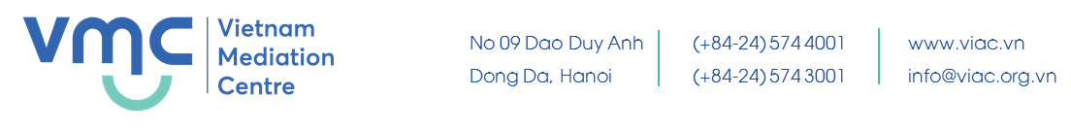
SAMPLE CURRICULUMN VITAE

MICHAEL HWANG |  |  |  | 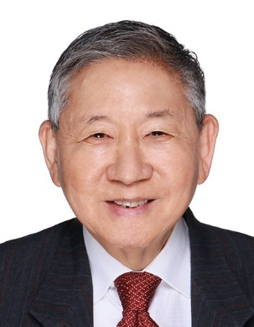
 | Date of birth ... 14 November 1943
 | Occupation (currently or/and formerly) Senior Counsel, Chartered Arbitrator and Accredited Mediator
 | Courier address 150 Beach Road #06-01 Gateway West Singapore 189720
 | Cell phone No.: (+65) 9616-9688 |  | Fasimile: (+65) 6291-4165
 | Email: michael@mhwang.com
 | Professional specialty Arbitration and Mediation
 | Language skills English, Mandarin (Spoken)
Education
Qualifications |  | Bachelor of Civil Law  Master of Arts
Major(s) |  | Law
University(s) |  | Oxford University
Work history
1968-1971 |  | Advocate & Solicitor, Allen & Gledhill
1972-1973 |  | Salaried Partner, Allen & Gledhill
1974-1991, 1993 – 2002 |  | Equity Partner, Allen & Gledhill
1991-1992 |  | Judicial Commissioner (Fixed Term Judge), Supreme Court of Singapore
2003–2010 |  | Sole Proprietor, Michael Hwang S.C.
2010-2014 |  | Sole Proprietor, Michael Hwang Chambers
2014-present |  | Sole Director, Michael Chambers LLC
Researches and papers
2000 |  | Co-author of “Mediation In Singapore: A Brief Overview” published in Asian Dispute Review, Issue 1, September 2000
2006 |  | Co-author of “ADR in East Asia”(Chapter in “ADR in Business – Practice and Issues across Countries and Cultures” page 147 (Editors : J.C. Goldsmith, Arnold Ingen – Housz and Gerald Pointon, Kluwer Law International, 2006)
2004 |  | Author of the chapter on “The Role of Arbitrators as Settlement Facilitators – Commentary” (International Council for Commercial Arbitration Congress Series No. 12 Beijing 2004, pp571 – 581)
2016 |  | Author of “Two Failed Mediations and the Lessons Learnt from Them” in Essays on Mediation: Dealing with Disputes in the 21st Century (Editor: Ian Macduff) (2016 Kluwer Law International, pp47 – 61)

